Run–Bike–Run
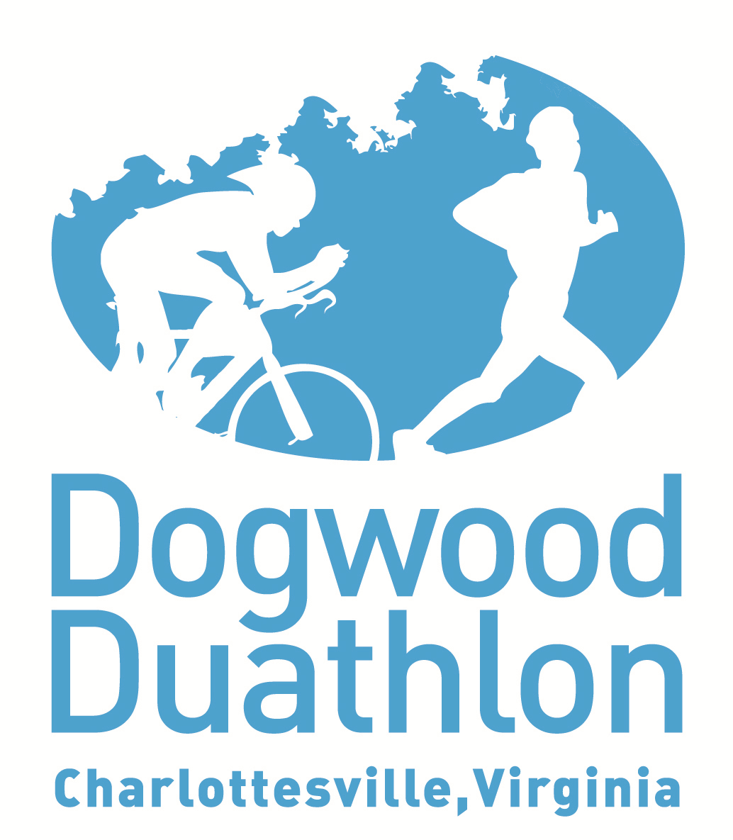
Join the fun!
For more information and to register online:
www.DogwoodDuathlon.com

Come participate with your friends in the 9th annual Dogwood Duathlon
OPEN TO ALL KIDS AGES 7-16
Date: Sunday, May 20, 2018
Time: 9:00 am
Where: Forest Lakes South Swim Club
Fee: $25 ($30 after 5/1) + USAT fee
Race Distances:
Ages 7–11 | - Run: ½ mile  - Bike: 2 miles  - Run: ½ mile
Ages 12–16 | - Run: 1 mile  - Bike: 4 miles  - Run: ½ mile

P.E. Challenge:
Any school that registers at least 30 participants will receive $100 for sports equipment for their school.
All finishers will
receive an award!
Lots of great prize drawings!

