Jesus Jog 5K and Prayer Pet Walk (1Mile)
Share the spirit of the Season
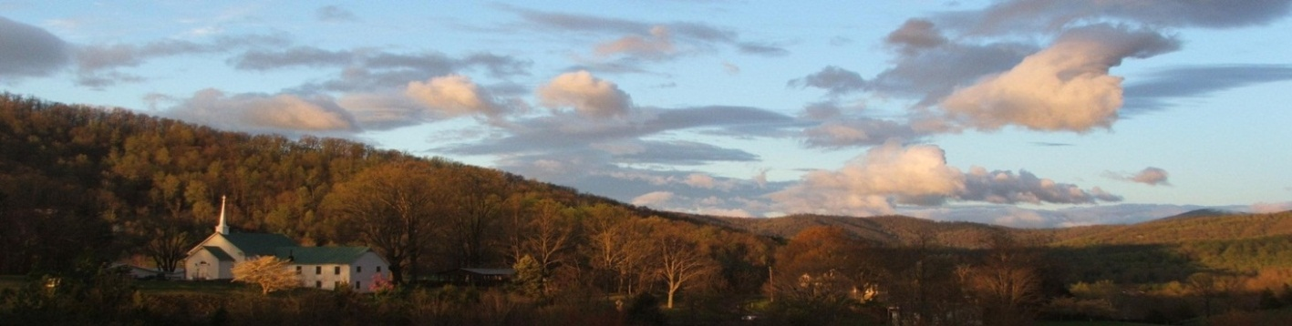

Beautiful out-and-back course with breathtaking mountain views!
*All funds raised from this run/walk will help with the building of a Peace Garden in Greene County*
Sunday, December 4, 2016
Measured, accurate 3.1 mile course
Race Event | Time | Entry Fee
Race Day Registration  Jesus Jog 5k | 1:00 p.m.  2:00 p.m. | $25 prior to November 1st, $30 prior to December 1st and $40 on race day
1 Mile run/walk/pet walk | 2:45 | $15 pre- registered, $20 race day
Awards | 3:15 | No Fee: Awards provided by Ragged Mountain Shop
Christmas Sing-Along | 3:30 | No Fee: Bring your spirit and voices to sing. A collection will be taken for the Peace Garden.

Mail entries to: Kendall Tata, 874 Madison Road, Stanardsville, VA 22973

Make checks payable to: “Mount Vernon Church” and write “Peace Garden” on the memo line.
Awards: Male and female overall and age group place prizes.
For more information: Kendall Tata at (757) 343-9908 or kendall.tata@gmail.com
Directions: From Rt. 29: Turn onto 33 West for 7.5 miles. Turn left onto Rt. 810 (Dyke Rd.) and go 2 miles. Church is on the left.
_ _ _ _ _ _ _ _ _ _ _ _ _ _ _ _ _ _ _ _ _ _ _ _ _ _ _ _ _ _ _ _ _ _ _ _ _ _ _ _ _ _ _ _ _ _ _ _ _ _ _ _ _ _ _ _ _ _ _ _ _ _ _ _ _ _
Jesus Jog 5K, 1-Mile Family Worship/Pet Walk Registration Form 2015
Last Name:_________________________________First Name:____________________________
Address:____________________________________City:_________________________State:_______Zip:__________
E-Mail:________________________________________Phone:________________________
Check one: 5K_______ 1-Mile Pet Walk_______
Age on Race Day:_____ Gender: M F T: Shirt (for Pre-registered 5K ONLY): Women: S M L XL Men: S M L XL XXL

RELEASE AND WAIVER OF LIABILITY, ASSUMPTION OF RISK, AND INDEMNITY, AND PARENTAL CONSENT AGREEMENT
In consideration of participating in the Peace Run 5K, 1-Mile Race, 1-Mile Family/Pet Walk and/or Tot Trot, I represent that I understand the nature of running events and that I and/or my minor child am qualified, in good health, and in proper physical condition to participate in such activities. I further acknowledge that the activity will be conducted over public roads and facilities open to the public during the activity and upon which traffic hazards are to be expected. I acknowledge that if I and/or my minor child believe event conditions are unsafe, I and/or my minor child will immediately discontinue participation in the activity. I fully understand that running events involve risks of serious bodily injury including permanent disability, paralysis and death, which may be caused by my own actions, or inactions, those of others participating in the event, the conditions in which the event takes place, or the negligence of the “releases” named below, and that there may be other risks either not known to me or not readily foreseeable at this time, and I fully accept and assume all such risks and all responsibility for losses, costs, and damages and I and/or my minor child incur as a result of my and /or my minor child’s participation in the activity. I hereby release, discharge and covenant not to sue Mount Vernon Church, its respective administrators, directors, agents, officers, volunteers and employees, other participants, any sponsors, advertisers, and if applicable, owners and lessors of premises on which the activity takes place (each considered one of the “Releasees” herein) from liability, claims, demands, losses, or damages on my account caused or alleged to be caused in whole or in part by the negligence of the “releasees” or otherwise including negligent rescue operations; and I further agree that if, despite this release, waiver of liability, and assumption of risk I, or anyone on my and/or my minor child’s behalf, makes a claim against any of the Releasees, I will indemnify, save and hold harmless each of the releasees from any loss, liability, damage or cost which may incur as the result of such a claim. I have read this RELEASE AND WAIVER OF LIABILITY, ASSUMPTION OF RISK, AND INDEMNITY AGREEMENT, AND PARENTAL CONSENTS AGREEMENT, understand that I have given up substantial rights by signing it and have signed it freely and without any inducement or assurance of any nature and intend it to be a complete and unconditional release of all liability to the greatest extent allowed by law and agree that if any portion of this agreement is held to be invalid the balance, notwithstanding, shall continue in full force and effect.
_____________________________________________________________________________Date____________________________________________ ______________________________________________________________________________________
Printed name of participant Signature of Participant (Only if age 18 or over)
I am unable to participate, but I would like to make a donation ______.
(Please send to Kendall Tata at the address above.)

