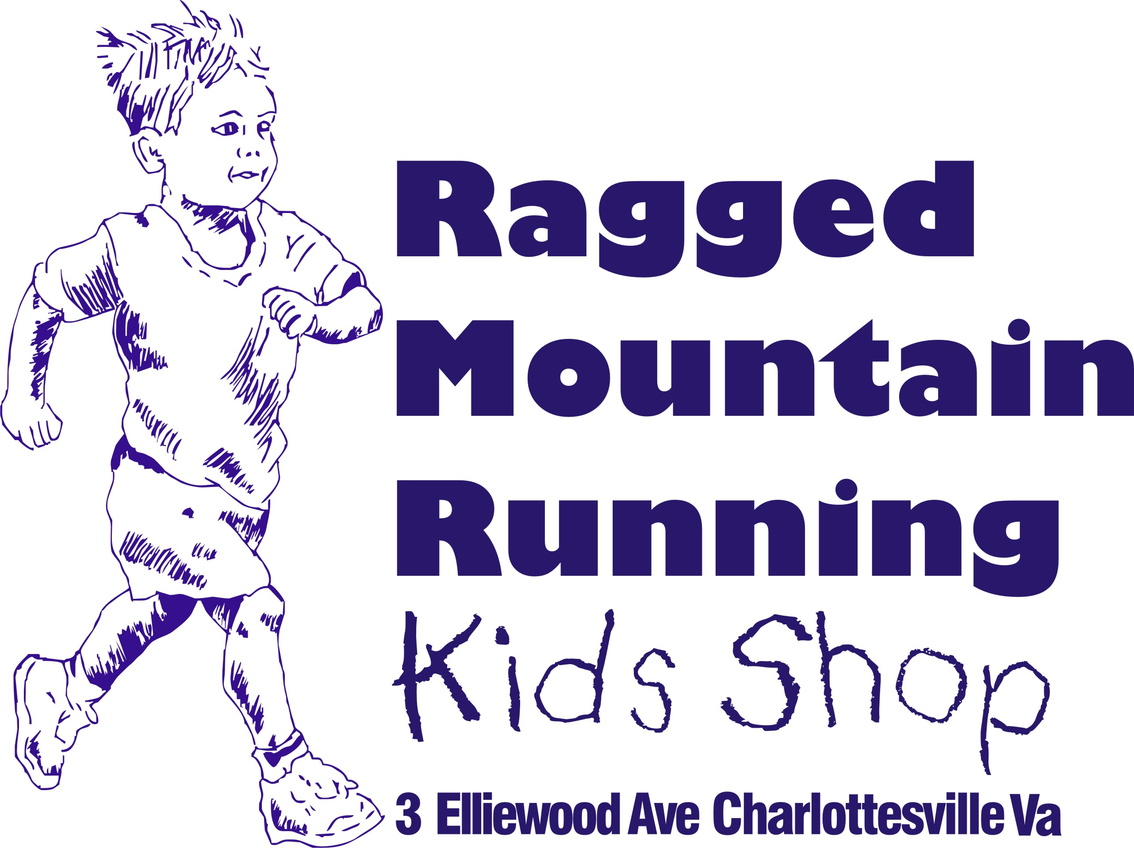

Presents
The 2015
Ragged Mountain Kids Running Camp
July 8th
8-11:30am

ALL children ages 5-12 welcome!
A fun and multi-dimensional introduction to running, to be held at Earlysville’s beautiful Panorama Farms

Campers receive a free T-shirt, water bottle and other goodies!
Activities will include the following:
-Pacing
-How to Beat the Hills
-Team Building, Relay Games
-Personal Goal Setting
-Running Lingo/Vocabulary/Etiquette
-Track and Field Events
-Form, Drills, Stretching
-Nutrition, Rest, Recovery
-Running Games

Healthy snacks and drinks will be provided.              
More detailed information will be emailed to campers as we get closer to camp time.
Questions:
RMRS: (434) 293-3367 (9:30a-6:00p)
Email: Camp Coordinators seandavidkeveren@gmail.com or Rcr7w@virginia.edu

Registration Form:
Child’s Name ________________________________________________________________________
Age (on camp day) _________________Sex ______________
T-Shirt Size (Circle One): Youth 6-8 Youth 10-12 Adult Small
Parent’s Contact Information: Name___________________________________________________________________
Email___________________________________________________________________
Street Address____________________________________________________________
City_____________________________State __________________Zip _____________
Phone __________________________________________________________________
Allergies or Medications ___________________________________________________

Please fill out completely. Incomplete forms will be sent back. Mail entries to Ragged Mountain Running Shop, 3 Elliewood Ave. Charlottesville 22903
Make checks payable to Ragged Mountain Racing
Camp Registration Fee $45/child (1 child)
$40/child (2 children) $
35/child (3 or more)
Family scholarships available on a case by case basis

I know that running is a potentially hazardous activity. I should not enter my child to the camp unless they are medically able to participate. I agree to abide by all decisions of the camp directors whether the child can continue to safely participate. I assume all responsibility for my child walking and running in this event, including but not limited to falls, contact with other participants, the effect of weather, including high heat and humidity. All such risk being known and appreciated by me. Having read this wavier and knowing these facts and in consideration of your excepting my entry, my child, and anyone entitled to act on their behalf, waive and release the Ragged Mountain Racing team from all claim or Liabilities of any kind of arising out of my child participating in this camp. I grant permission to all the foregoing to use photographs, motion pictures, recordings, or other record of this event for any legitimate purpose.
Parent Signature ______________________________________ Date _______________
Please return form and waiver to:
Ragged Mountain Running Shop
3 Elliewood Avenue Charlottesville, Virginia 22903

